***PRIVILEDGED & CONFIDENTIAL***

ALLERGY ALERT: KIND Issues Voluntary Recall Due to Undeclared Sesame Seeds in Oats & Honey Granola

July 7, 2020 (New York, NY) – KIND Healthy Snacks (KIND) is voluntarily recalling a limited number of Oats & Honey Granola with Toasted Coconut pouches due to the presence of sesame seeds, which is not listed as an ingredient in the product. The label does list “sesame seeds” under the “May Contain” statement.

People who have an allergy or sensitivity to sesame seeds should immediately discontinue use of this product. No allergic reactions have been reported to date. This product may be safely consumed by those who do not have an allergy or sensitivity to sesame seeds.

KIND recently decided to transition away from using sesame seeds in its Oats & Honey Granola recipe. This limited recall was initiated after KIND discovered that the product’s previous recipe was used and placed into new packaging that did not disclose sesame seeds as an ingredient.

The recall applies to one flavor: KIND Oats & Honey Granola with Toasted Coconut. No other KIND products are affected by this recall.

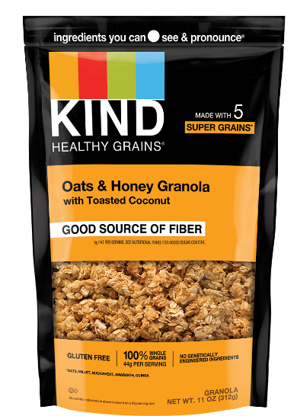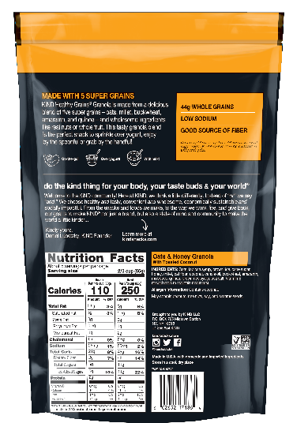
Caption: KIND Oats & Honey Granola with Toasted Coconut in the 11oz pouch

The product is sold in a plastic pouch and is available in two sizes – 11 ounces (UPC: 60265217186-4) or 17 ounces (UPC: 60265225101-6).

The impacted product can be identified by looking for the Best By date, which is located on the bottom of the pouch:
- For the 11oz pouch, the Best By dates range from April 4, 2021 to June 1, 2021
- For the 17oz pouch, the Best By dates range from April 30, 2021 to June 1, 2021

Please visit kindsnacks.com/oatsandhoneygranola for more information.

The product was manufactured in the United States and distributed through retail stores and ecommerce sites. This limited voluntary recall is being conducted in cooperation with the U.S. Food and Drug Administration.

Consumers who have purchased KIND Oats & Honey Granola that displays one of the abovementioned Best By dates, and can no longer consume the product safely due to an allergy or sensitivity to sesame seeds, should retain the packaging and email customerservice@kindsnacks.com.

Media Contact:
Jenna Thornton
203-803-3653
jthornton@kindsnacks.com

