URGENT FOOD PRODUCT RECALL

September 28, 2020

[INSERT CUSTOMER NAME AND ADDRESS]

Action Requested: Recall of A Specific Code Date of SKIPPY® Super Chunk Peanut Butter Distributed by Hormel Food Sales, LLC

Dear Valued Customer,

Hormel Foods Sales LLC is voluntarily recalling 15,352 cases, or 187,755 total pounds, of a single code date of SKIPPY® Super Chunk Peanut Butter due to the possibility that some jars may contain slightly elevated aflatoxin levels.

Product Information:

Product | Recalled Code Date
SKIPPY® Super Chunk Peanut Butter, 16.3 oz | Best if Used By SEP2921

Complete details regarding the recalled product, including the product label, are set forth in Attachment A to this letter.

IMPORTANT: This recall relates only to 16.3-ounce jars of SKIPPY® Super Chunk Peanut Butter with the specific code date indicated above. No other SKIPPY® or HORMEL products are affected.

No illnesses or injuries have been reported in association with this recall.

Action Requested

- Please immediately examine your inventory and quarantine any product subject to recall, including finished product incorporating any of the products listed above.

- Please destroy any of the affected product that you have in your possession.

- Please provide us with information on the amount of recalled product, if any, that you have in your possession.

- Please complete and return the enclosed Recall Effectiveness Check form as soon as possible.

- If you further distributed/sold any of the recalled product in the form in which it was received, please identify your customers, notify them at once of this recall and provide them with a copy of this letter.

This recall is being carried out to the retail level. This recall is being made with the knowledge of the U.S. Food and Drug Administration.

If you require more information, please contact Samantha Allen, Hormel Foods Corporate Quality Control at 847-715-8871 or via email at SRAllen2@Hormel.com

Your prompt attention to this matter is appreciated.

Should you have questions, please contact your Hormel Foods Sales Representative.

Sincerely
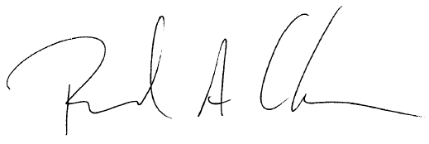

RICHARD A. CARLSON
Vice President, Quality Management

ATTACHMENT A
Recalled Product Details

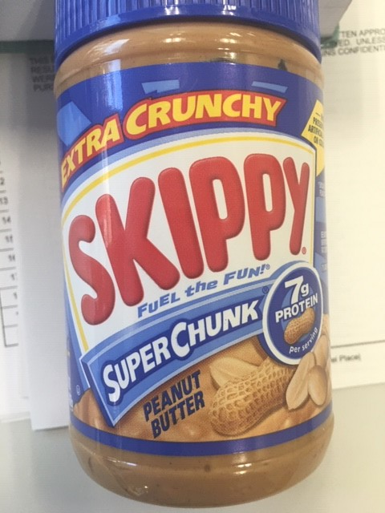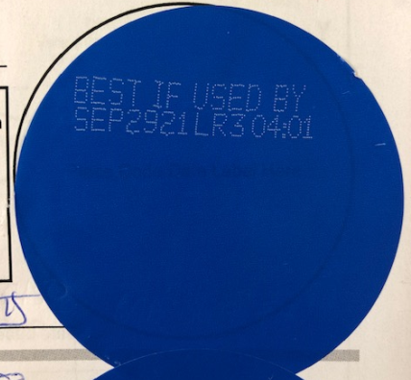

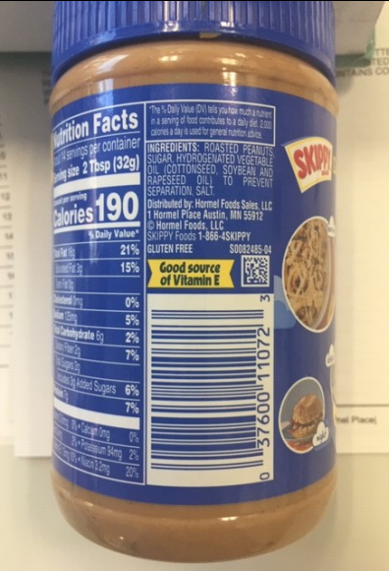
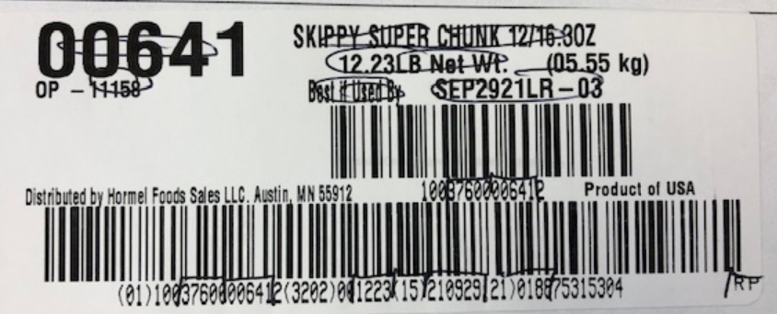

RECALL EFFECTIVENESS CHECK

Customer Response Form for SKIPPY product recall of September 2020

Date: ______________, 2020

Please check ALL appropriate boxes.

□ I have read and understand the recall instructions provided in the September 2020 letter

□ My company did not receive any shipments of the recalled product (If checked, please skip remaining questions, sign, date and return to your HORMEL FOODS Sales Contact.

□ I have checked my stock and have quarantined inventory consisting of the following: (Identify product and quantity in stock and quarantined)

Indicate disposition of recalled product:

□ Returned / held for return (Specify quantity, date and method)

□ Destroyed (Specify quantity, date and method)

□ Quarantined pending correction (Specify quantity, date and method)

□ I have identified and notified my customers that were shipped or may have been shipped the following product(s) (Specify product, quantity, notification date, and notification method, attaching documents as necessary):

Have you received any reports of illness or injury related to the recalled product(s)?

□ YES □ NO

If yes, please explain:

Please check the appropriate box(es) to describe your business

□ wholesaler/distributor □ retailer

□ grocery corporate headquarters □ food service/restaurant

□ repacker □ manufacturer

□ Other:

Signature:
Name:
Title:
Tel. Number:
Email:

Firm Name:
Address:
City/State:
Country:

Please email completed form to Samantha Allen at SRAllen2@Hormel.com

