2/22/2020

Dear valued Tillamook retail partner,

During our recent ice cream size change, from 1.75QT to 1.5QT, we identified an issue at one of our sites where leftover 1.75QT lids were applied to 1.5QT product. This only impacted one flavor, Chocolate Peanut Butter, and one production run at this plant. Through our research we have found that you have received some of this product.

There is NO health or safety issue with this product. The only issue is the lid reflects a size of 1.75QT, and the container reflects a size of 1.5QT. At this time, we are asking that you please hold any product matching the product information, detailed below, in your distribution centers and work with your Tillamook sales representative to arrange pick-up. Any product that is currently in stores can be destroyed and your Tillamook sales representative can help arrange for credit.

We apologize for the impact that this may cause. If you have any additional questions, please contact your Tillamook sales representative who will be able to answer any questions. Thank you very much for your continued support.

See below for listing of affected products:

ITEM GTIN  (000-72830) | CASE GTIN  (000-72830) | PRODUCT DESCRIPTION | CASE PACK | Batch Number | Bottom Code | Shipping from Warehouse
08116-0 | 67116-3 | Chocolate Peanut Butter 1.5 qt | 6 | 20210116MK00001 | TL 41-80 | W111
 |  | URM Code # 94128-6

Sincerely,
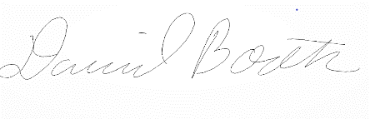
David Booth
Executive Vice President of Sales

