**Slime Licker® Sour Rolling Liquid Candy**

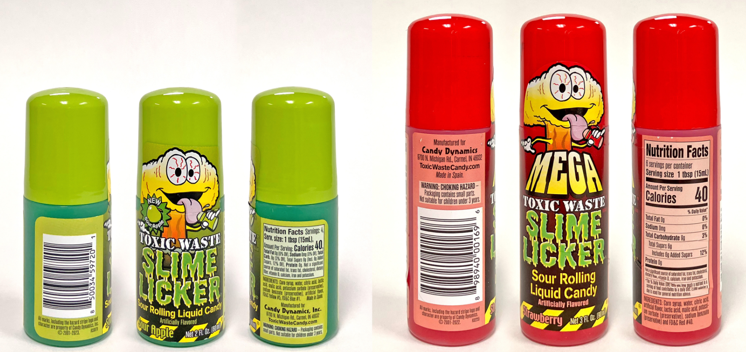

|  |  |
| --- | --- |
|  |  |

**PRODUCT**: Slime Licker® Sour Rolling Liquid Candy

|  |  |  |
| --- | --- | --- |
| **Brand Name** | **Model Name/Number** | **UPC Code** |
| Slime Licker® Sour Rolling Liquid Candy (Blue Razz & Strawberry) | 2 oz./45001 | 8-98940-00101-6 |
| Slime Licker® Sour Rolling Liquid Candy (Blue Razz & Strawberry) | 2 oz., 2 pack /45002 | 8-98940-00191-7 |
| Mega Slime Licker® Sour Rolling Liquid Candy (Blue Razz & Strawberry) | 3 oz./46090 | 8-98940-00169-6 |
| Slime Licker® Sour Rolling Liquid Candy (Black Cherry& Sour Apple) | 2 oz./44060 | 8-50034-59720-1 |
| Slime Licker® Sour Rolling Liquid Candy (Blue Razz & Strawberry) | 2 oz. / CDN-45001 | 0-60631-91829-7 |

**HAZARD**: Choking hazard as to rolling applicator ball

**REMEDY**: Full refund for consumers returning non-empty product

**QUESTIONS**: Call toll-free at 877-546-0483 from 8 a.m. to 5 p.m. ET Monday through Friday or online at [www.CandyDynamicsRecall.expertinquiry.com](http://www.CandyDynamicsRecall.expertinquiry.com) or at [www.CandyDynamics.com](http://www.CandyDynamics.com) for more information.

**This recall is being conducted in cooperation with the U.S. Consumer Product Safety Commission.**

Post for 120 days after recall launch

**RECALL NOTICE**