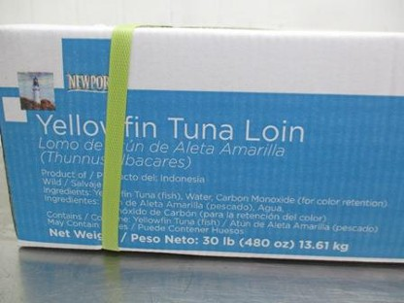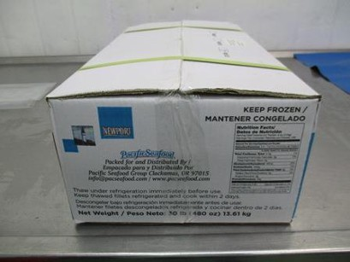RELISH FOODS, INC.
5730 UPLANDER WAY SUITE 110, CULVER CITY, CA 90230
TEL: 310.568.0038 FAX: 310.568.0198

On October 13, 2017, Relish Foods, Inc of Culver City, California voluntarily initiated the recall of
Frozen Newport Brand 5/8 LB Tuna Loins (Lot #s MTNT 0947C, MTNT 0957B, MTNT 0967A,
MTNT 0977D). The recall has since expanded to include, 3/5 LB Tuna Loins (Lot #s MTNT 0917B,
MTNT 0937D), additional lots of 5/8 LB Tuna Loins (Lot #s GND 0737D, GND 0747E, GND 0757A,
GND 0767C and GND 0777B), 4 OZ Tuna Steaks (Lot # GND 0697B), and 6 OZ Tuna Steaks (Lot #s
GND 0707C, GND 0727A).

URGENT: FOOD RECALL
RE: NEWPORT BRAND 3/5 & 5/8 TUNA LOINS
Lot Nos. MTNT 0947C, MTNT 0957B, MTNT 0967A, MTNT 0977D
MTNT 0917B, MTNT 0937D
GND 0737D, GND 0747E, GND 0757A, GND 0767C, GND 0777B

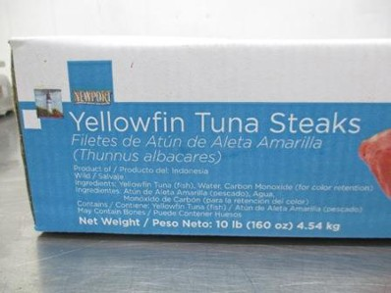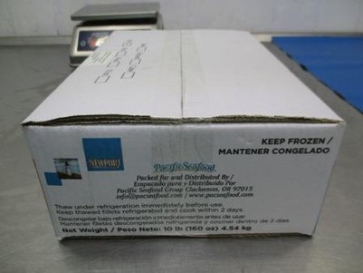
RE: NEWPORT BRAND 4 oz and 6 oz TUNA STEAKS
Lot Nos. GND 0697B, GND 0707C, GND 0727A

Recent tests show that the above lot numbers of this product have the potential to be contaminated with
Salmonella, an organism which can cause serious and sometimes fatal infections in young children,
frail or elderly people, and others with weakened immune systems. Healthy persons infected with
Salmonella often experience fever, diarrhea (which may be bloody), nausea, vomiting and abdominal
pain. In rare circumstance, infection with Salmonella can result in the organism getting into the
bloodstream and producing more severe illnesses such as arterial infections (i.e., infected aneurysms),
endocarditis and arthritis.

Please examine your stocks immediately to determine if you have any of Lot Nos. MTNT 0947C, MTNT 0957B, MTNT 0967A, MTNT 0977D, MTNT 0917B, MTNT 0937D, GND 0737D, GND 0747E, GND 0757A, GND 0767C, GND 0777B, GND 0697B, GND 0707C, GND 0727A on hand. If so, please discontinue distributing the lot and promptly QUARANTINE and put on RECALL HOLD

