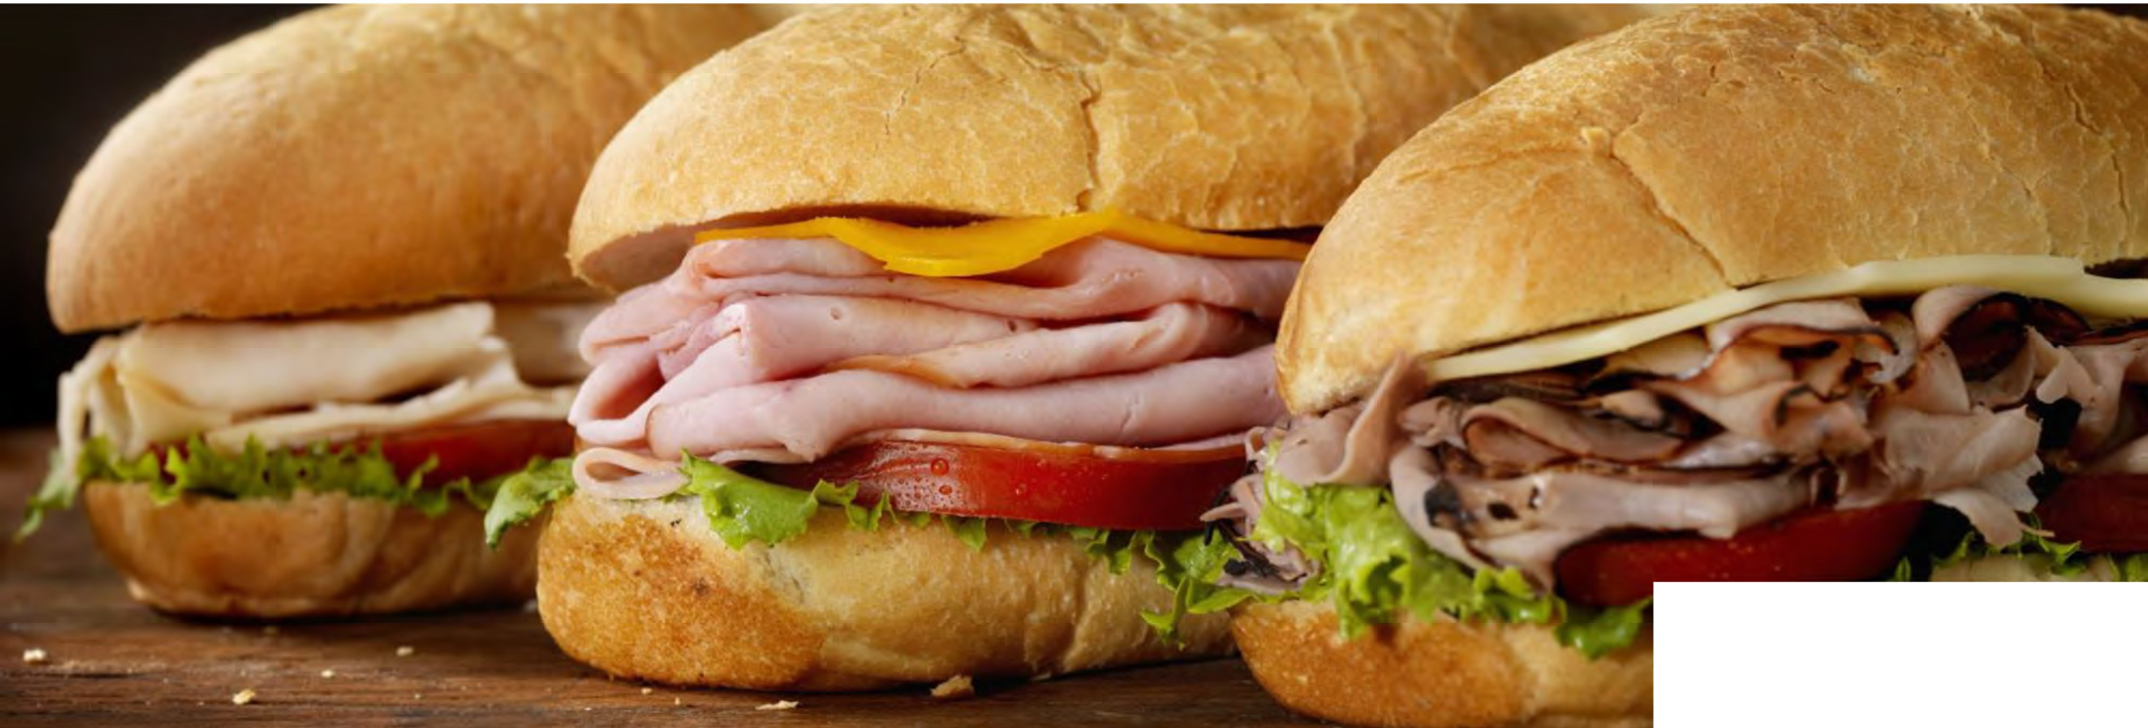
■VenturaFoods ®

Sandwiches

Strategic Insights & Category Management

In this issue

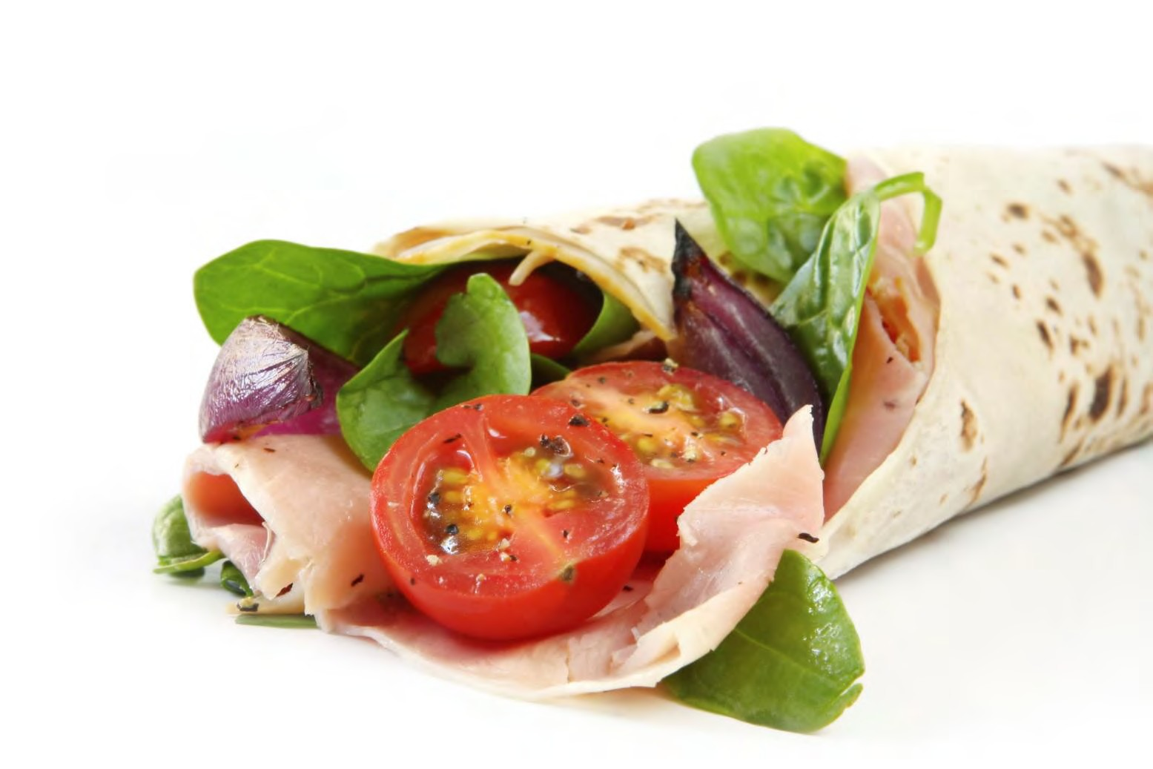Growing pains
- Sides as toppings
- Crafted vs. customized
New photo
- Regional sandwiches
- Alternative proteins

  - 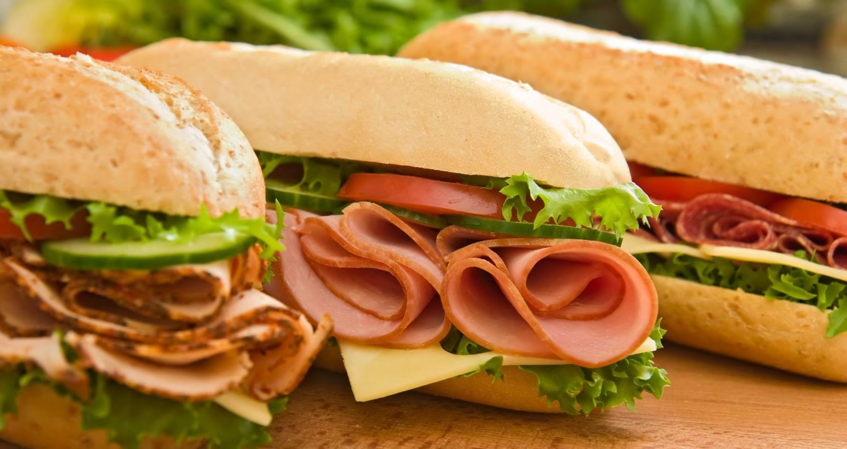Despite significant growth from some emerging fast-casual sandwich chains such as Jersey Mike’s and Modern Market, Top 500 sandwich chains grew cumulative sales at just 0.1% in 2017 and unit count dropped 0.9%. Likewise, fast casuals continue to gain share of the LSR sandwich market, as many QSRs struggle to grow sales.
-2.6%
year-over-year sales decline of Top 500 QSR
sandwich chains
Growing pains

  - Other players, such as fried chicken or Mediterranean fast casuals, are aiming to steal share with high-quality, unique and ethnic sandwich varieties. And yet another growing pain, some consumers have traded down to sandwiches prepared at home over the past two years despite an improving economy.

  - A balance of innovation and affordability is needed from
Look for:
sandwich operators to grow away-from-home consumption.

Look for:
- Operators to face a growing need to differentiate their sandwiches, especially with new carriers, proteins and toppings, ethnic inspirations and over-the-top indulgences
- Major sandwich chains, especially Subway, putting forth millions for concept and menu refreshes

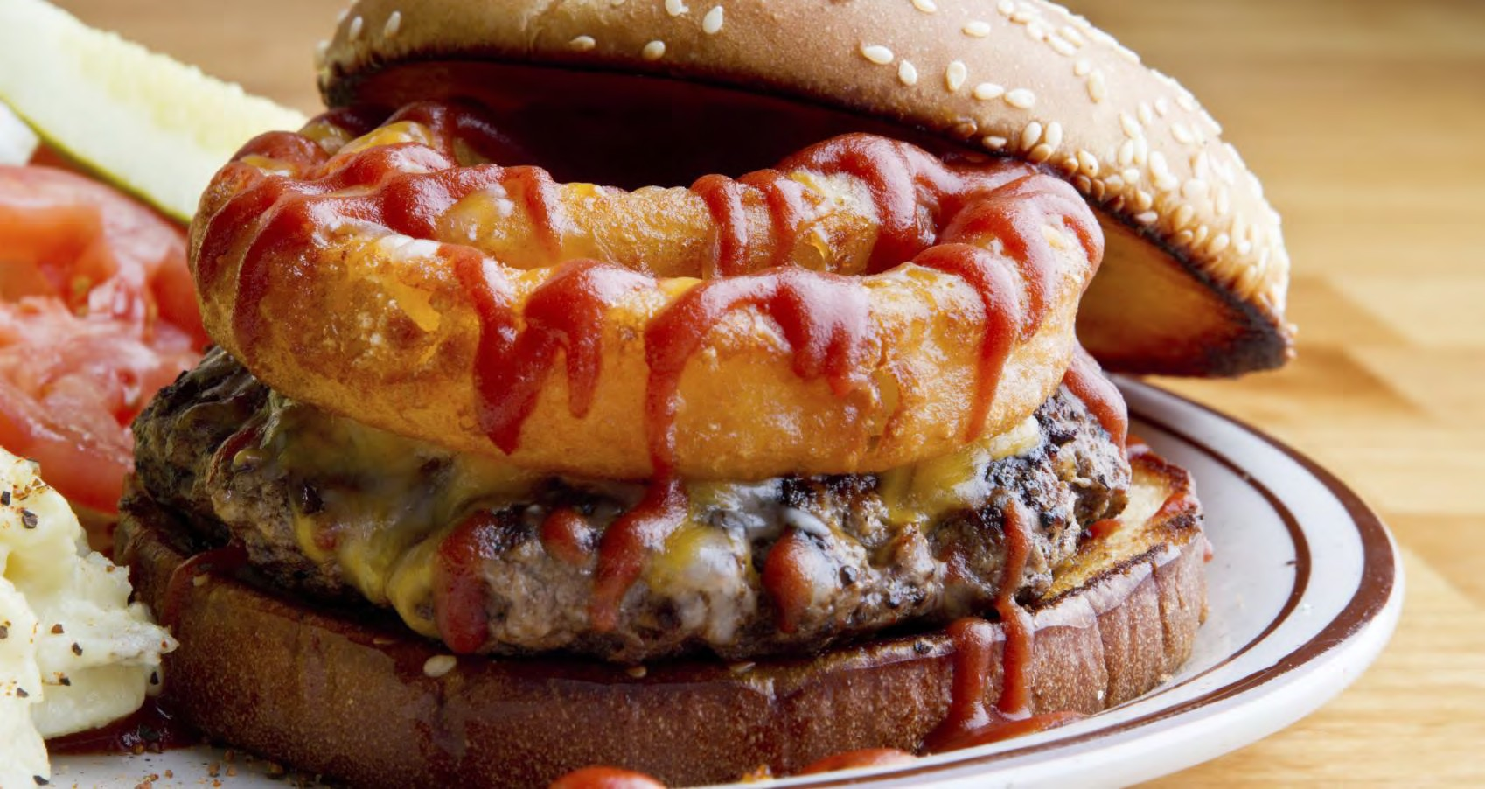
Sides as toppings
34%
of consumers strongly agree that they like to add sides as toppings to their
sandwiches

    - One way operators are differentiating their sandwiches is by topping them with ingredients that are traditionally plated as sides. Fries, potato wedges, potato chips, onions rings and other components are all making their way atop sandwiches.

    - Operators are especially promoting these types of sandwich builds as limited-time offers to drive menu interest. For operators and suppliers, it is a cost-effective way to cross-utilize ingredients and create new signature sandwiches.

    - Crispy, fried toppings add a crave-worthy element to sandwiches, while imparting texture, differentiated flavor profiles and overall indulgence.
Look for:
- More menus to expand the range of sides that are suitable as toppings, such as macaroni and cheese, mashed potatoes and gravy or refried beans
- Seasonal sides to also come into play, such as
sweet potatoes during the fall or winter
Look for:

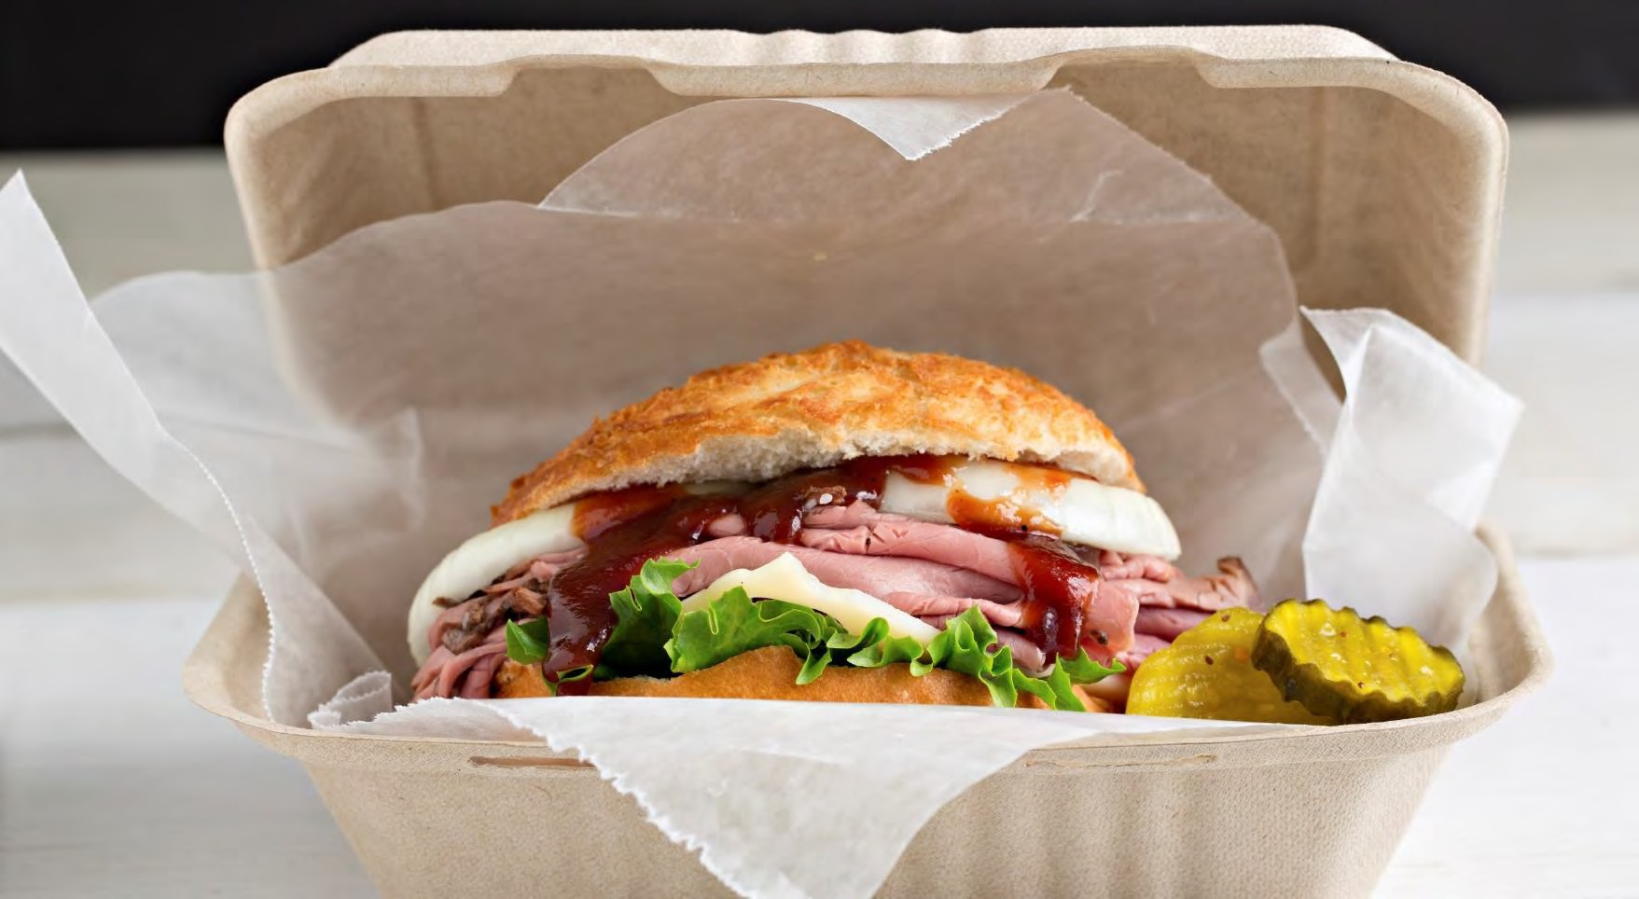
Crafted vs.
customized
50%
of 18- to 34-year-olds would like restaurants
to offer more sandwiches with new or unique flavors and
ingredients

- The make-your-own model has become synonymous with the fast-casual restaurant segment. While over the years consumers have been gravitating to formats that give them the ability to choose their own ingredients in an assembly-line format, their ever-changing expectations for uniqueness and differentiated experiences may eventually cause a shift in the opposite direction.

- Shift has already been seen in many of the independent and newly emerging sandwich chains that are bucking against the fast-casual customization trend.
Look for:

Look for:
- Chef-crafted sandwich builds to more fully emerge in the fast-casual arena to elevate the menu
- More quick-service operators to partner with award-winning chefs for crafted creations, and marketing of those chefs on menus and in advertising

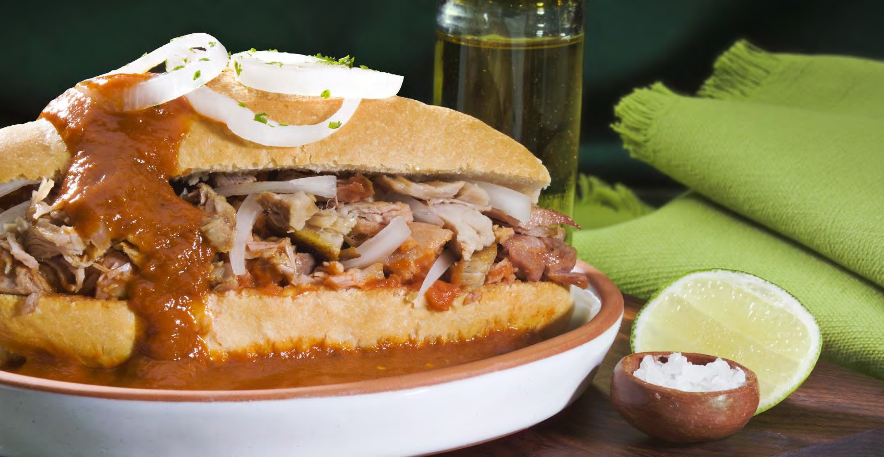Regional
sandwiches
10%
increase of Montreal bagel mentions on menus in the past year

- American cuisine is anchored by regional preferences and culinary traditions, and one region’s favorite food is often seen as truly unique or even odd to people in another region. At a time when consumers are more food-savvy and endlessly curious about flavors than ever before, there could be prime opportunity in promoting regional influences for sandwiches.

- Southern fare provides a wide array of inspiration for regional sandwiches, from fried bologna sandwiches topped with pimento cheese to vegetarian options featuring fried green tomatoes or collard greens.

- Regional and global mashups call for new twists on the classic grilled Cuban sandwich and unique fillings to dress up Montreal bagel sandwiches.
Look for:

Look for:
  - More top chains to experiment with lesser-known regional sandwich varieties, such as Buffalo, N.Y.’s beef on weck and Louisville’s hot brown
  - Experimentation into regions beyond the U.S., such as Yucatan, Mexico-style sandwiches

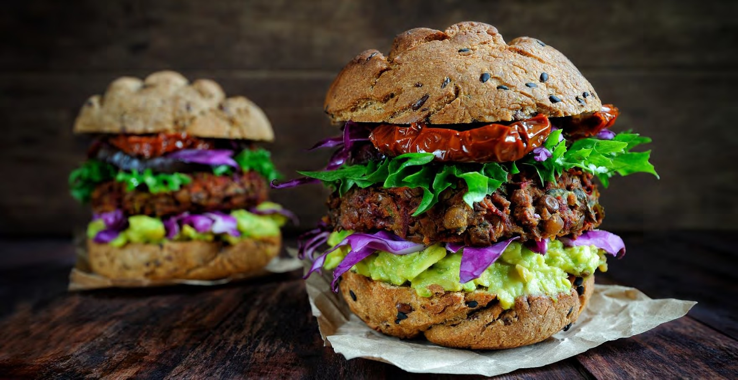
Alternative
proteins
37%
of Gen Zers are interested in trying sandwiches with alternative meat
options

    - Alternative proteins have been getting a lot of attention in the burger category, with plant-based Impossible Burger meat being used in new veggie-burger options at better-burger chains such as Epic Burger and M
Burger.

    - Smoked Eel Burger, recently listed at Shake Shack. Such innovation is due to carry over into the sandwich category, which is already experiencing a spate of sandwich offerings that feature differentiated proteins.

    - Arby’s routinely menus venison as an LTO, and elk and bison are appearing as sandwich fillings at more upscale sandwich purveyors.
Look for:
Look for:
- Operators to answer the call for top-notch vegan sandwich components with alternatives that truly mimic the taste and texture of meat—most notably, jackfruit
- More mainstream operators to look to nontraditional game meats for ultra- limited, limited-time offers

SANDWICHES
Key Conclusions

1 2 3

- Sandwiches are experiencing softness even with new, rapidly growing concepts such as Jimmy John’s and Jersey Mike’s. Consumers are looking for differentiation in their sandwich experience.
- items such as bowls are also driving a decline in
sandwich consumption

- Look to include distinctive ingredients to create a crave-worthy sandwich that appeals to consumers.

- Ingredients such as a unique spread (savory jam, alternative sauces) or an alternative protein can create a new experience for consumers
- Use texture as a differentiating element to a traditional ‘soft’ sensory experience

- Consider items such as crunchy fried onions, potato chips, crisp pickles or kimchee to create a multi- sensorial experience that can drive crave-ability

- Look to unique side dishes to differentiate the traditional sandwich. Mashups can create a unique experience through an LTO program.
- As Generation Z comes into their prime spending years, they have an expectation for authentic experiences – whether regional cuisine or ethnic cuisine.

- Look to the southern cuisine for inspiration as a beloved profile for consumers. Smoky flavors, Sweet Heat BBQ sauces, comfort of Mac and Cheese can serve as inspiration for new menu items.

- Move towards authentic ethnic flavors – familiar with a twist will devolve into more authentic flavors as Gen Z grows into the core consumer.

